SOP-10102 for Decanting of Liquid Nitrogen from a Pressurised Dewar To be customised for local equipment/ arrangements
ONLY TRAINED OPERATORS SHOULD USE THIS EQUIPMENT
 |  |  | 

Potential hazards | - Asphyxiation due to inhalation of oxygen depleted atmosphere (Liquid Nitrogen can expand by almost 700 times its level of liquid when vaporised by to gas – displacing oxygen in enclosed spaces).  - Exposed skin contact with cryogenic liquid at -196°C can cause cold burns or frostbite.

Procedure
- Always decant from a pressure vessel in a well ventilated area  - Wear appropriate personal protective equipment (lab coat, cryogenic safety gloves, trousers and safety boots) and a functioning portable oxygen depletion alarm. | 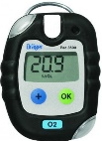 | To operate depletion alarm:  - Ensure unit is in clear air.  - Switch on by pressing and holding the operator button for 3 seconds until light flashes.  - Wait for the monitor to go through the warm up sequence.  - Check the sensor is within calibration date.
- Check the type, quantity and pressure of the cryogenic liquid in the supply vessel.  - Check the transfer/ filling hose is suitable for purpose and there is no damage to the braiding or connection threads.  - Ensure the supply vessel pressure is ≤10 psi by checking the vessel pressure gauge - reduce excess vessel pressure by opening the vent valve until levels drop.  - Place an appropriate receiving flask/ transport dewar on a stable floor surface which is impervious to liquid nitrogen.  - Never leave flask unattended when filling up.  - Purge the filling hose with gas from the supply vessel by cracking open the decant valve.  - Wait until the hose is very cold before putting it into the open vessel. Use the cold gas to pre-cool warm vessels.  - Slowly open the supply vessel decant valve, initially gas will be generated due to the heat of the hose boiling the liquid.  - Continue to transfer liquid until the agreed volume has been transferred or the vessel is full to the bottom of the neck tube.  - Do not stand in the vapour cloud during filling.  - Close the supply vessel valve.  - Carefully remove the decant hose from the vessel and store appropriately.  - Place the correct lid or stopper in the vessel neck.  - Do not travel in the lifts with the full dewar. | 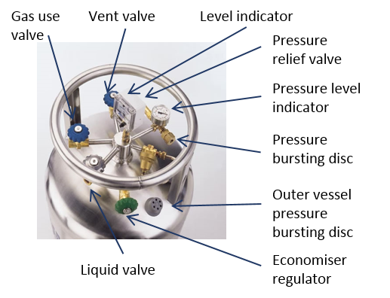

If alarm goes off during decanting procedure, step away from the dewar into fresh air and allow vapours to dissipate.

For further information see associated risk assessment for decanting of liquid nitrogen.
More information can be found on the H&S website: www.swansea.ac.uk/healthsafety

Document Control
Document Name | Standard Operating Procedure for Decanting of Liquid Nitrogen from Pressurised Dewars
Document Ref. Number | SOP-10102
Revision | 2.0
Date of Issue | July 2018
Written By | Gretta Roberts
Amended by | Andy Lee
Reviewed by | H&S Leads
Contact Email | healthandsafety@swansea.ac.uk

Amendment Record
Revision | Date | Amendment(s)
0 |  | Draft
1 | July 2018 | New operating procedure
2 | May 2021 | Reviewed

