First Aid Emergency | Argyfwng Cymorth Cyntaf
Landline | Llinell dir  Zoom call | Galwad Zoom  333  Security Emergency Number |  Rhif Argyfwng Diogelwch |   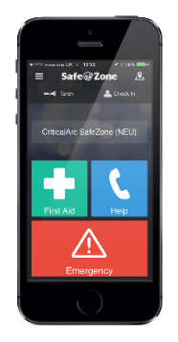 |  | Mobile | Ffôn Symudol  01792 513333    Security Emergency Number |  Rhif Argyfwng Diogelwch
Your location | Eich lleoliad: Building, floor, location
Nearest defibrillator | Diffibriliwr agosaf: Building, floor, location
333 and SafeZone Emergency –  Security will:  connect you to 999 and monitor the call direct the emergency services to you  send a first responder, if required |  | 333 ac Argyfwng SafeZone –  Bydd y tîm Diogelwch yn:  - eich cysylltu chi â 999 a monitro'r alwad  - cyfeirio’r gwasanaethau brys at eich lleoliad  - anfon ymatebwr cyntaf, os oes angen
Local First Aiders | Swyddogion Cymorth Cyntaf Lleol
Name | Enw | Phone | Ffôn | Location | Lleoliad
 | 01792 (xx)xxxx
Security (24/7) |  Diogelwch (24/7) | 01792 (60)4271 | Singleton Campus & Bay Campus |  Campws Singleton & Campws Bae
Out of hours: Use the SafeZone App or contact Security – 01792 (60)4271
Allan o oriau: Defnyddiwch yr App SafeZone neu cysylltwch â Diogelwch – 01792 (60)4271

Faculty | Cyfadran:
Date | Dyddiad:

